|  |  |
| --- | --- |
| **WC Logo.emf** | **Staff Report to the Weber County Commission**  *Weber County Planning Division* |
|  | |

****Synopsis****

****Application Information****

**Application Request:** A public hearing to consider and take action on a request to vacate the side and rear 10’ public utility easements within lot 5 of Fenster Farm Subdivision Phase 2.

**Agenda Date: Tuesday, June 14, 2022**

**Applicant:** Hayden Wadsworth, Owner

**File Number:** EV 2022-04

****Property Information****

**Approximate Address:** 5448 W 560 N, Ogden, UT

**Project Area:** .92 acres

**Zoning:** A-1 Zone

**Existing Land Use:** Residential

**Parcel ID:** 15-710-0001

**Township, Range, Section:** T7N, R1E, Section 20

****Adjacent Land Use****

**North:** Residential **South:** Residential

**East:** Residential **West:** Residential

****Staff Information****

**Report Presenter: Felix Lleverino**

flleverino@co.weber.ut.us

**801-399-8767**

**Report Reviewer:** SB

Background and Summary

The applicant is requesting to vacate the side and rear ten-foot easements within lot 5 of Fenster Farm Subdivision Phase 2.

West Warren Water District, Rocky Mountain Power, and Questar Gas have been notified of the petition. The Questar Gas Company and Rocky Mountain Power have provided consent letters to the request.

A vacation ordinance, seen in Exhibit B, is the chosen instrument to execute the vacation. Weber County Engineering has provided written consent to the public utility easement vacation request. The Weber County Attorney has reviewed the ordinance and approved it.

Summary of County Commission Considerations

The County Commission will need to determine if there will be any detrimental impacts caused by vacating the proposed public utility easements. Utah Code §17-27a-609.5 states that *“The legislative body may adopt an ordinance granting a petition to vacate some or all of a public street, right-of-way, or easement if the legislative body finds that:*

*(a) good cause exists for the vacation; and*

*(b) the public interest or any person will not be materially injured by the proposed vacation.*

Conformance to the General Plan

Vacating the identified easement will not contradict the West Central Weber General Plan.

Staff Recommendation

Staff recommends approval of the request to vacate the side and rear ten-foot easements within lot 5 of Fenster Farm Subdivision Phase 2. This recommendation for approval is subject to all review agency requirements.

The recommendation is based on the following findings:

1. Vacating the proposed public utility easement is not contrary to the Western Weber General Plan.
2. Based on the proposed subdivision amendment, good cause exists to vacate the easement.
3. The public interest or any person will not be materially injured by the proposed vacation.

Exhibits

1. Easement Vacation Narrative
2. Vacation Ordinance

Location Map

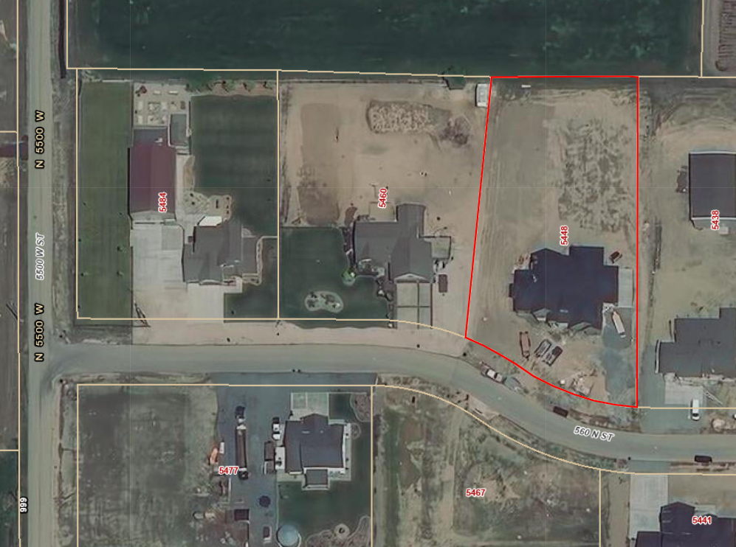

Exhibit A

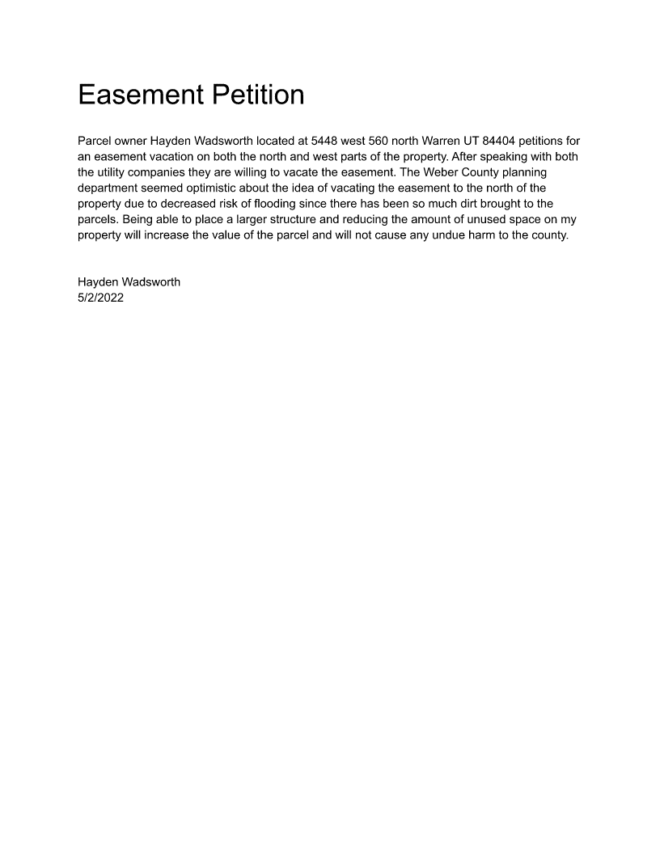

Exhibit B

**Ordinance No.**

**An ordinance of Weber County vacating the side and rear 10’ Public utility easements within lot 5 of the Fenster farm subdivision phase 2**

**WHEREAS,** the Owner has filed a petition to vacate the side and rear public utility easements within lot 5, Fenster Farm Subdivision Phase 2, as depicted in Exhibit A of this ordinance; and

**WHEREAS,** after providing proper public notice, a public hearing was held before the Weber County Commission on June 14, 2022, regarding the vacation of the public utility easements; and

**WHEREAS,** Weber County’s Engineering Department has been notified and has provided written approval of the public utility easement vacation; and

**WHEREAS,** the Commission finds that good cause exists to vacate the public utility easement, and that it will not substantially affect the Ogden Valley General Plan, and that neither the public interest nor any person will be materially injured;

**NOW THEREFORE,** the Board of County Commissioners of Weber County ordains as follows: the side and rear ten-foot public utility easements within Lot 5, Fenster Farm Subdivision Phase 2 are hereby vacated, as depicted in Exhibit A of this ordinance.

This Ordinance shall be effective 15 days after publication in the Standard Examiner.

Adopted and ordered published this 14th day of June 2022.

Weber County Commission

By_________________________________

Scott Jenkins, Chair

Commissioner Jenkins Voted

Commissioner Harvey Voted

Commissioner Froerer Voted

ATTEST:

_________________________________

Ricky Hatch, CPA

Weber County Clerk

Exhibit A

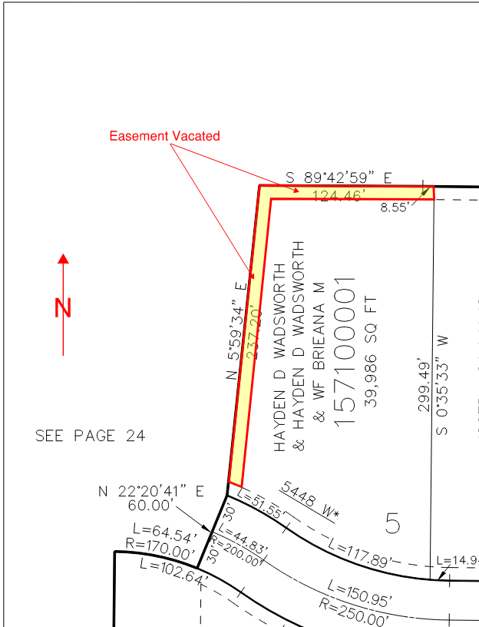

Recorder’s plat 22-136